Nicolas Shelley

Java CIT 244

12/3/20

Professor Winyard

This project is a base for a text-based adventure with a few basic functions premade.

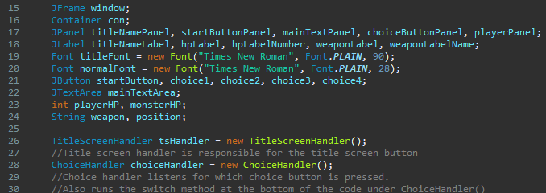

The title screen handler and choice handler control the buttons in the program. Any changes that need to happen with these handlers must happen within the respective classes.

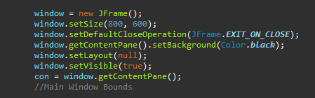

This Section of code is for the main bounds of the game screen. If the game text will not fit on screen the window.setSize will need to be adjusted to be larger.

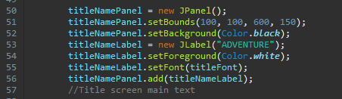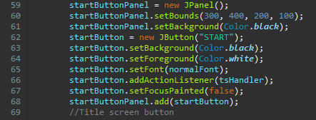

These functions are responsible for handling the title screen.

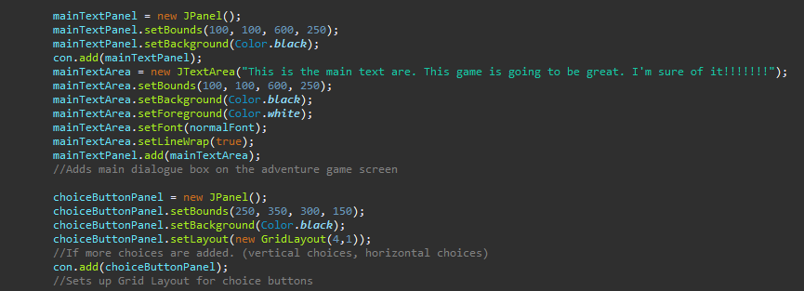

This sets up the main game screen that displays the text and choice buttons. The main text area size can be edited by changing the (mainTextArea.setBounds(x coordinate, y coordinate, width, height);) Though if size is changed the main screen size will need to be changed as well.

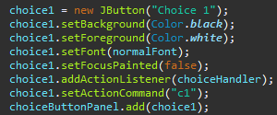

Above is the Swing code need for a choice button

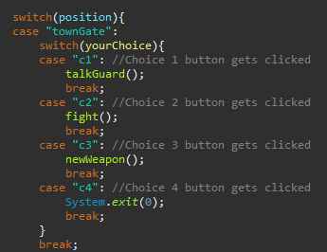

This is part of the switch statement for choice buttons. Any new function must have the corresponding location variable.

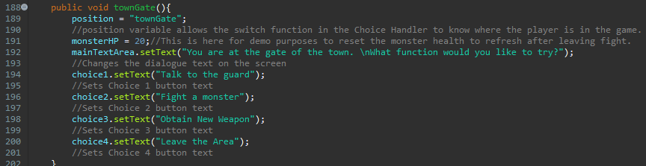

This is the function for a choice that would appear on the main text screen for the adventure.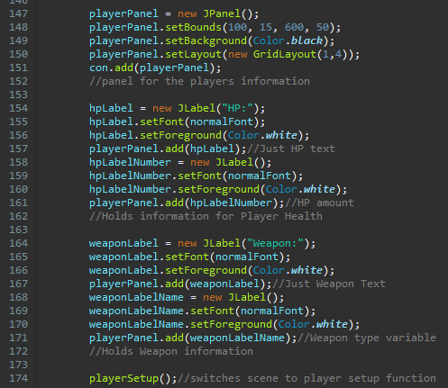

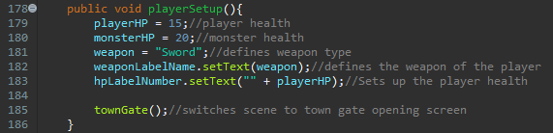

The above code is all the code necessary for the player variables. If more player variables were to be added the grid layout must be adjusted.

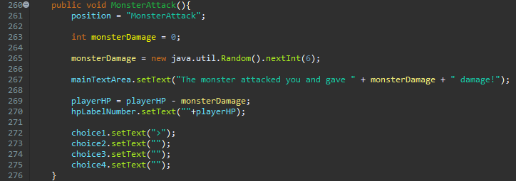

The monster attack function is just a simple random number function that then subtracts from the players health.